**Module 11 Final Assignment – Mohammed Abdin**

**Submission Instructions:**

Your submission for this assignment should be a Word document that includes the following screenshots, each labeled for the step that the screenshot represents:

1. A screenshot of VS Code showing app.py from the file Module 11 Final Assignment.zip.

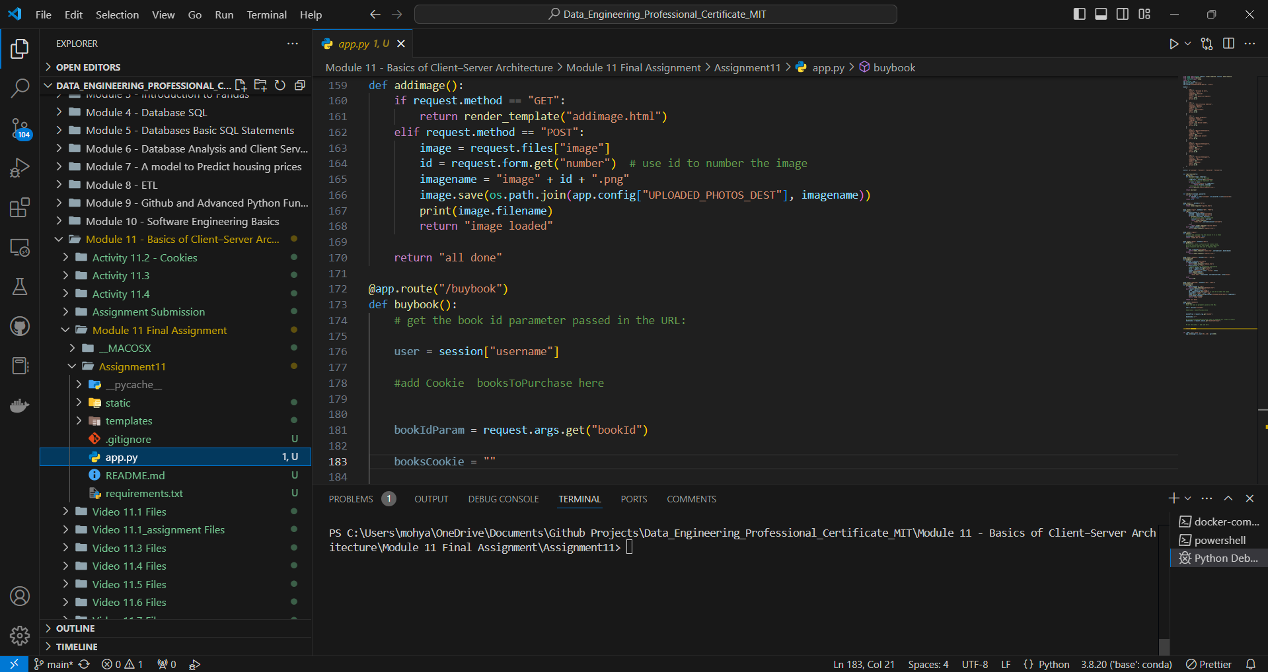

1. A screenshot of the web browser pointing to “<http://localhost:5000>” and showing the application running.

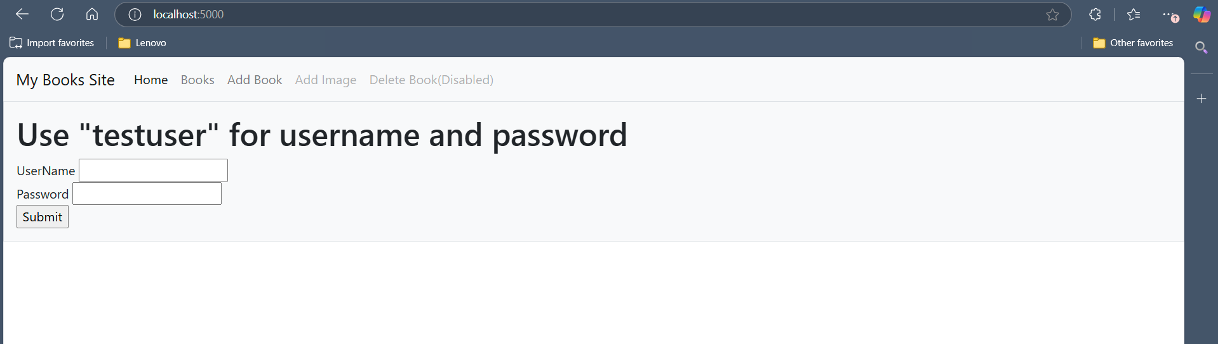

1. A screenshot of the Books table modified using Bootstrap.

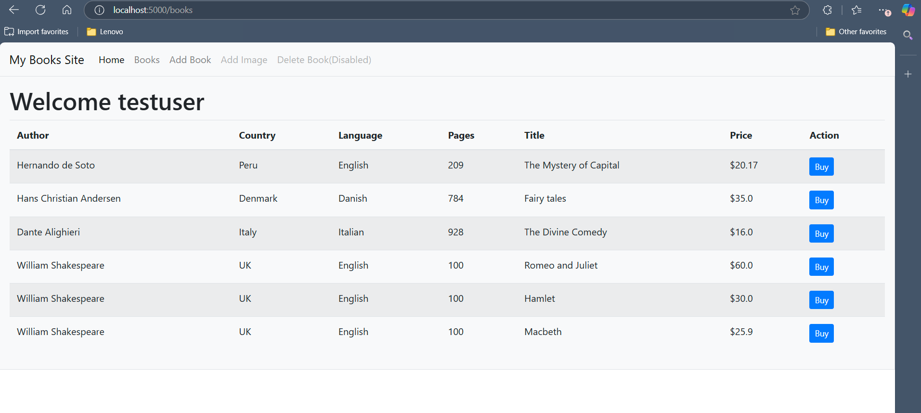

1. Complete the code and provide:
   1. A screenshot showing that the booksToPurchase *cookie* has been added to app.py.

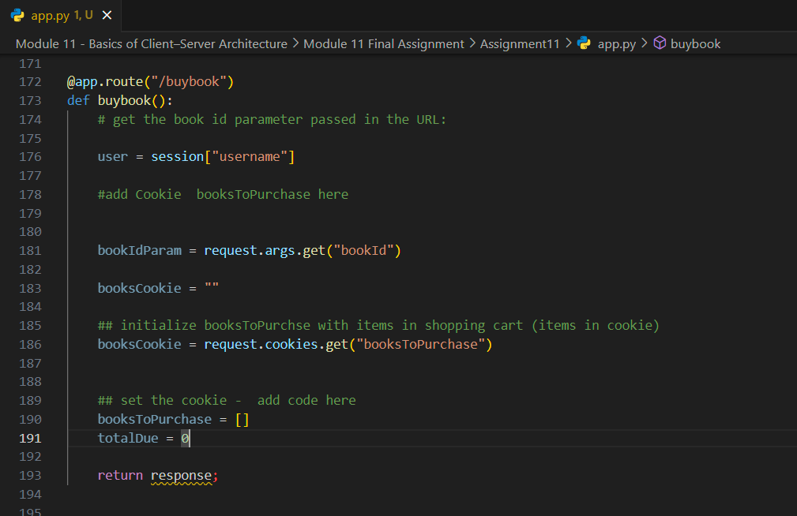

* 1. A screenshot of the *for loop* used to find the book that a user wants to purchase.

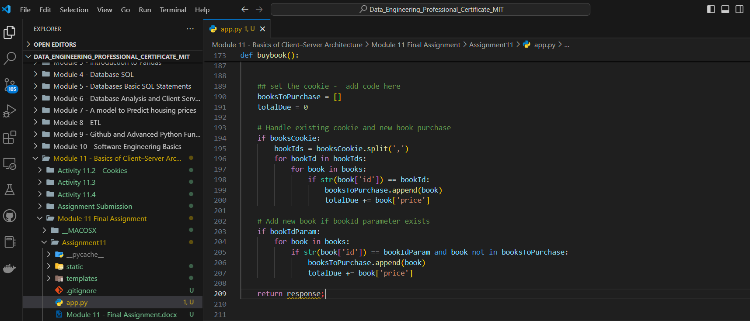

* 1. A screenshot showing that you set the *cookie* booksToPurchase with the updated list of bookId.

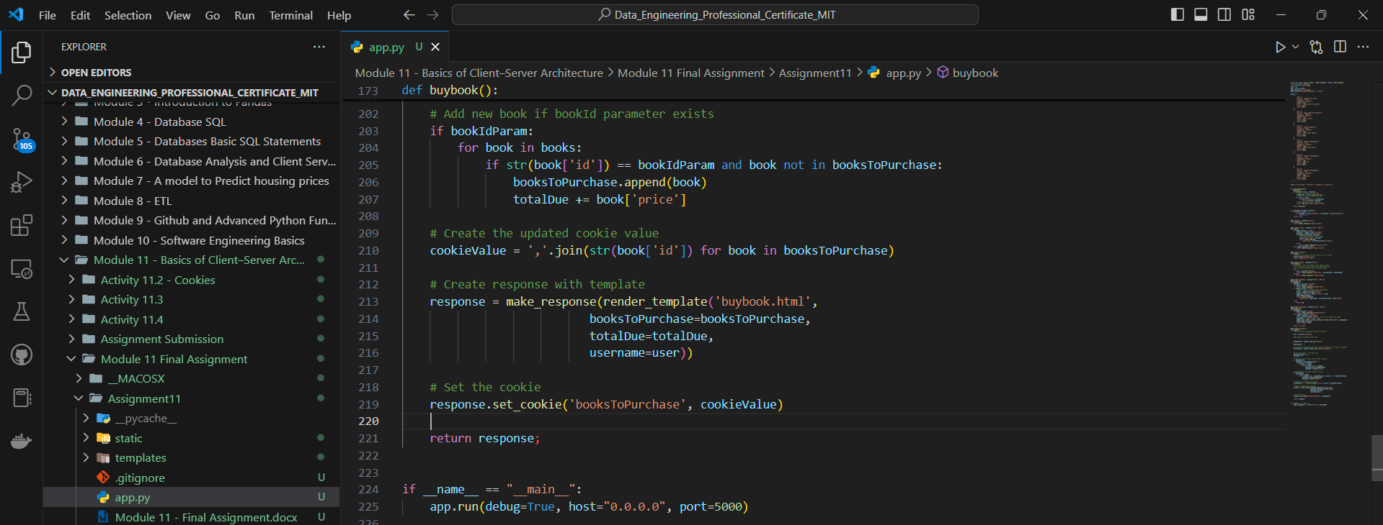

* 1. A screenshot showing that you returned the correct response object.

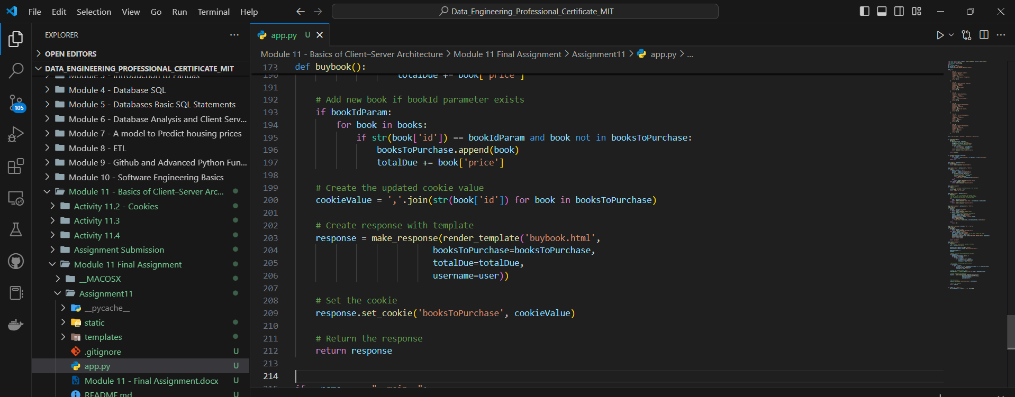

1. A screenshot showing that you created a striped table of the books you want to purchase.

